Use Case Specification Document

1. Introduction

1.1 Purpose
This document outlines the detailed use case specifications for the KriGo Vehicle Rental Marketplace System. It defines the interactions between actors and the system to support the operations of car rental companies all over Algeria.

1.2 Scope
It is a centralized market place where customers can search and book vehicles, rental agencies can operate and administrators can oversee the system.
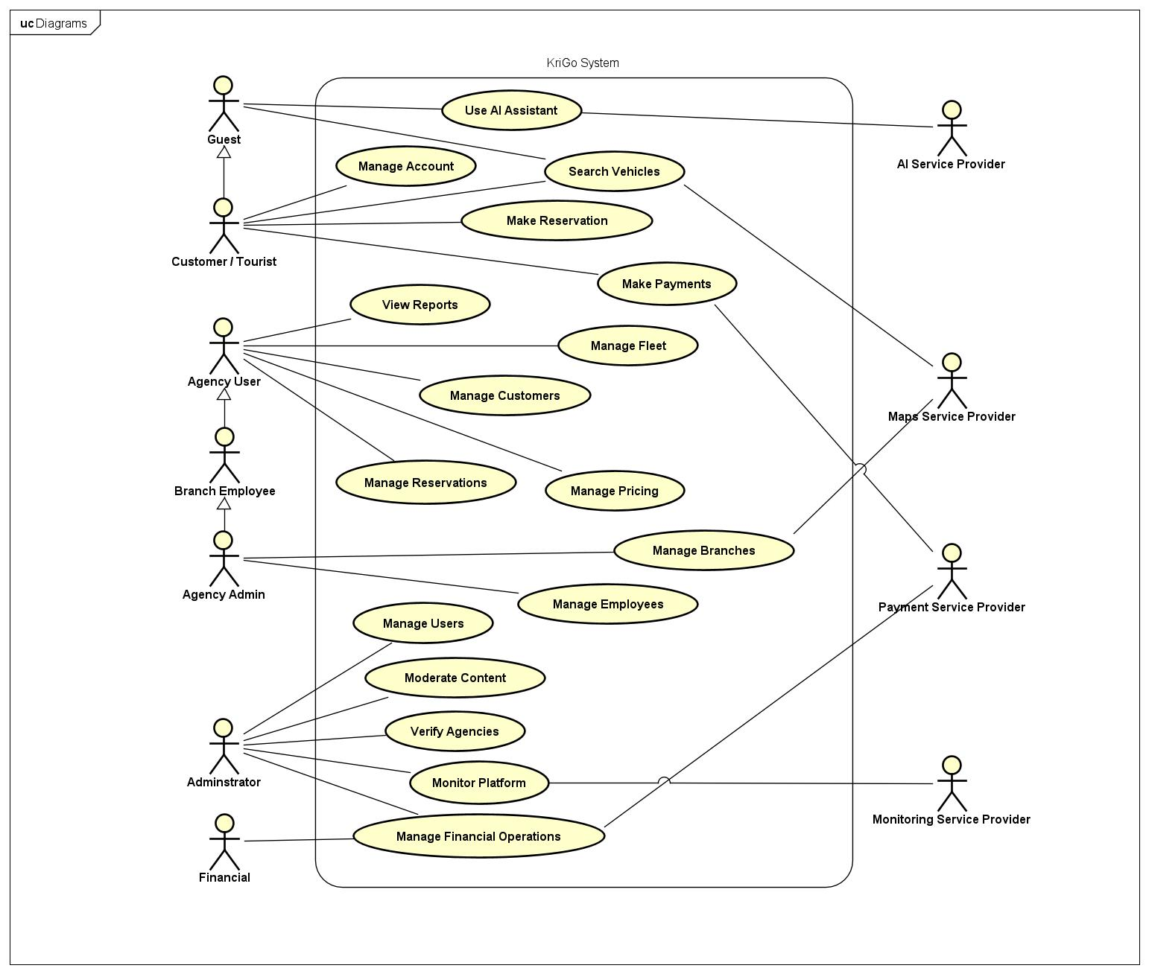
Figure 1 Overview System Use Case Diagram

2. Actors
The Krigo system consists of different actors who interact with the platform to accomplish specific goals according to their roles and permissions. Actors: End users (customers, guests) Internal users (rental agencies with different levels of access) External service providers (payments, maps, AI, system monitoring, etc.) Every actor has a different role to play to keep the system running efficiently and as a whole.

Actor | Description
Administrator | The highest authority in the system who manages users, content, and verifies agencies.
Financial | Responsible for managing and overseeing all financial operations.
Agency User | A system user with limited permissions to manage fleet, reservations, and related tasks.
Rental Agency Admin | Has full control over the agency and its branches, including financial transactions.
Agency Branch Employee | A standard user whose operations are restricted to a specific branch.
Customer/Tourist | A user who can search, book services, and complete payments.
Guest | An unverified user with limited access who becomes a customer after registration.
AI Service Provider | Provides artificial intelligence services to support system functionality.
Payment Service Provider | Handles and verifies electronic payment transactions.
Map Service Provider | Provides map data and location-based services
Monitoring Service Provider | Delivers system monitoring and traffic tracking services
Table 1 System Actors

3. Use Cases
(Administration)
UC-01: Manage Users
Trigger: Administrator selects the user management function.
Goal: Allow administrators to manage customer, agency, and staff accounts.
Primary Actor: Administrator
Preconditions
- Administrator is authenticated.
- User accounts exist in the system.
Main Success Scenario
- Administrator opens the user management page.
- System displays all registered users.
- Administrator selects a user account.
- Administrator views account information.
- Administrator modifies account details or account status.
- System validates the changes.
- System updates the user account.
Alternative Flows
A1. Invalid account information → System requests correction.
A2. User account not found → System displays an error message.
Extension Points
- Activate Account
- Suspend Account
- Deactivate Account
Postconditions
- User account information is updated.
- Changes are recorded in the audit log.
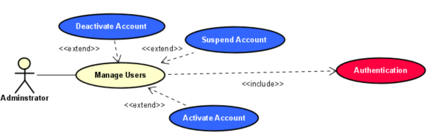

UC-02: Moderate Content
Trigger: Administrator accesses the content moderation module.
Goal: Allow administrators to review and manage user-generated content.
Primary Actor: Administrator
Preconditions
- Administrator is authenticated.
- User-generated content exists.
Main Success Scenario
- Administrator opens the content moderation dashboard.
- System displays reviews, ratings, reports, and complaints.
- Administrator selects content for review.
- Administrator evaluates the content.
- Administrator approves, edits, or removes the content.
- System updates the content status.
Alternative Flows
A1. Content violates platform policies → System removes the content.
A2. Content requires further review → System flags the content.
Extension Points
- Handle Dispute
- Suspend User
Postconditions
- Content status is updated.
- Moderation actions are logged.
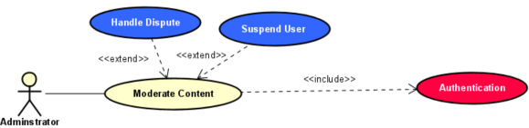
UC-03: Verify Agency
Trigger: Administrator receives a new agency registration request.
Goal: Allow administrators to verify rental agency registration applications.
Primary Actor: Administrator
Preconditions
- Administrator is authenticated.
- Agency application exists.
Main Success Scenario
- Administrator opens the agency verification module.
- System displays pending agency applications.
- Administrator selects an application.
- System displays agency information and submitted documents.
- Administrator verifies the provided information.
- Administrator proceeds to review the application.
Alternative Flows
A1. Required documents are missing → System requests additional documentation.
A2. Verification fails → Administrator rejects the application.
Extension Points
- Review Agency Application
Postconditions
- Agency verification status is updated.
- Platform/Agency Agreement Initialized.

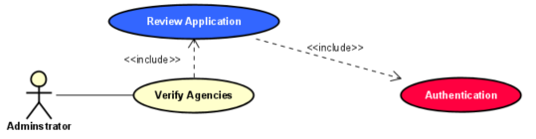
UC-04: Manage Financial Operations
Trigger: Financial staff accesses the financial management module.
Goal: Allow authorized personnel to monitor and manage platform financial transactions.
Primary Actor: Financial Officer
Secondary Actor: Payment Service Provider
Preconditions
- Financial officer is authenticated.
- Payment services are operational.
Main Success Scenario
- Financial officer accesses the financial operations dashboard.
- System displays financial transactions and reports.
- Financial officer reviews payment records.
- Financial officer verifies transaction status.
- Financial officer performs required financial operations.
- System updates financial records.
Alternative Flows
A1. Payment verification fails → System displays an error message.
A2. Transaction data unavailable → System requests synchronization.
Extension Points
- Generate Financial Report
- Process Refund
Postconditions
- Financial records are updated.
- Transaction activities are logged.

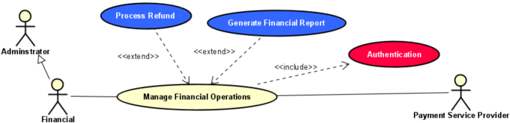
UC-05: Monitor System
Trigger: Administrator or monitoring service provider initiates system monitoring.
Goal: Allow authorized personnel to monitor platform performance and usage.
Primary Actor: Administrator
Secondary Actor: Monitoring Service Provider
Preconditions
- User is authenticated.
- Monitoring services are operational.
Main Success Scenario
- Administrator opens the monitoring dashboard.
- System retrieves operational metrics.
- System displays platform statistics and performance indicators.
- Administrator reviews system status.
- Administrator identifies issues or anomalies.
- System records monitoring activities.
Alternative Flows
A1. Monitoring service unavailable → System displays an error notification.
A2. Critical issue detected → System generates an alert.
Extension Points
- Generate Report
- Send Alert
Postconditions
- System status information is displayed.
- Monitoring events are logged.
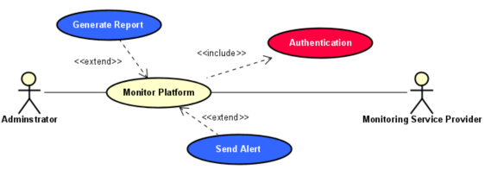

UC-06: Handle Dispute
Trigger: Administrator receives a dispute report or complaint.
Goal: Allow administrators to manage and resolve disputes between customers and rental agencies.
Primary Actor: Administrator
Secondary Actor: Customer, Rental Agency
Preconditions
- Administrator is authenticated.
- A dispute record exists in the system.
Main Success Scenario
- Administrator opens the dispute management module.
- System displays pending disputes.
- Administrator selects a dispute.
- System displays dispute details and supporting information.
- Administrator reviews the dispute.
- Administrator records a decision and updates the dispute status.
- System notifies the involved parties.
Alternative Flows
A1. Additional evidence required → Administrator requests further information.
A2. Dispute cannot be resolved immediately → Administrator escalates the dispute.
Extension Points
- Escalate Dispute
- Resolve Dispute
Postconditions
- Dispute status is updated.
- All actions are recorded in the audit log.

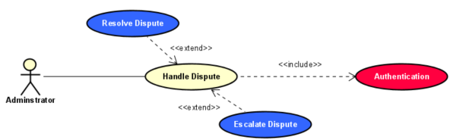

UC-6.1: Escalate Dispute
Trigger: Administrator determines that a dispute requires higher-level review.
Goal: Allow administrators to escalate unresolved disputes.
Primary Actor: Administrator
Preconditions
- A dispute exists.
- Administrator is authenticated.
Main Success Scenario
- Administrator opens the dispute record.
- Administrator selects the escalation option.
- Administrator enters escalation details.
- System forwards the dispute to the designated authority.
- System updates the dispute status.
Alternative Flows
A1. Escalation destination unavailable → System displays an error.
Postconditions
- Dispute status changes to "Escalated".

UC-6.2: Resolve Dispute
Trigger: Administrator decides to finalize a dispute.
Goal: Allow administrators to close disputes after reaching a resolution.
Primary Actor: Administrator
Preconditions
- Administrator is authenticated.
- A dispute exists.
Main Success Scenario
- Administrator reviews the dispute.
- Administrator determines the resolution.
- Administrator records the final decision.
- System updates the dispute status to resolved.
- System notifies the involved parties.
Alternative Flows
A1. Resolution information incomplete → System requests additional details.
Postconditions
- Dispute is marked as resolved.
- Resolution details are stored in the audit log.

UC-07: Review Agency Application
Trigger: Administrator selects a verified agency application.
Goal: Allow administrators to review agency registration requests.
Primary Actor: Administrator
Preconditions
- Administrator is authenticated.
- Agency verification has been completed.
Main Success Scenario
- Administrator opens the agency application.
- System displays all submitted information and documents.
- Administrator reviews the application.
- Administrator determines whether the application meets requirements.
- Administrator records the review decision.
Alternative Flows
A1. Information is incomplete → Administrator requests additional information.
Extension Points
- Approve Agency
- Reject Agency
Postconditions
- Application review status is updated.

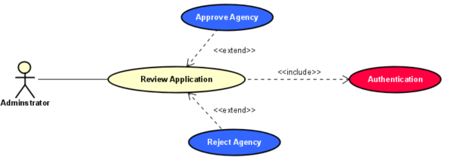
UC-07.1: Approve Agency
Trigger: Administrator approves an agency application.
Goal: Allow administrators to authorize a rental agency to join the platform.
Primary Actor: Administrator
Preconditions
- Agency application review is completed.
- Application satisfies all requirements.
Main Success Scenario
- Administrator selects the approve option.
- System validates the approval conditions.
- System activates the agency account.
- System grants access privileges.
- System notifies the agency.
Alternative Flows
A1. Approval validation fails → System displays an error.
Postconditions
- Agency account is activated.
- Agency can access platform services.

UC-07.2: Reject Agency
Trigger: Administrator rejects an agency application.
Goal: Allow administrators to deny agency registration requests.
Primary Actor: Administrator
Preconditions
- Agency application review is completed.
Main Success Scenario
- Administrator selects the reject option.
- Administrator enters the rejection reason.
- System records the rejection decision.
- System notifies the agency.
Alternative Flows
A1. Rejection reason is missing → System requests justification.
Postconditions
- Agency application is rejected.
- Rejection reason is stored.

(Agency Management)
UC-08: Manage Branches
Trigger: Agency administrator selects branch management.
Goal: Allow agency administrators to manage agency branches.
Primary Actor: Agency Admin
Secondary Actor: Maps Service Provider
Preconditions
- Agency administrator is authenticated.
Main Success Scenario
- Agency administrator opens branch management.
- System displays existing branches.
- Agency administrator adds, edits, or removes branches.
- System validates branch information.
- System updates branch records.
Alternative Flows
A1. Invalid branch information → System requests correction.
Extension Points
- Add Branch
- Edit Branch
- Remove Branch
Postconditions
- Branch information is updated.

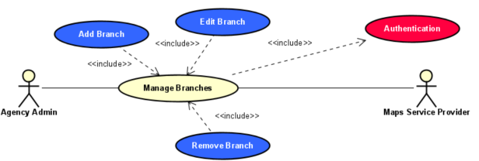

UC-8.1: Add Branch
Trigger: Agency administrator selects add branch.
Goal: Create a new agency branch.
Primary Actor: Agency Admin
Precondition: Agency administrator is authenticated.
Main Success Scenario
- Administrator enters branch information.
- System validates the data.
- System creates the branch.
- System stores branch location information.
Alternative Flows
A1. Invalid information → System requests correction.
Postcondition: New branch is created.

UC-8.2: Edit Branch
Trigger: Agency administrator selects a branch to edit.
Goal: Modify branch information.
Primary Actor: Agency Admin
Precondition: Branch exists.
Main Success Scenario
- Administrator selects a branch.
- System displays branch details.
- Administrator updates information.
- System validates changes.
- System saves updates.
Alternative Flows
A1. Validation fails → System displays an error.
Postcondition: Branch information is updated.

UC-8.3: Remove Branch
Trigger: Agency administrator selects remove branch.
Goal: Delete an agency branch.
Primary Actor: Agency Admin
Preconditions
- Branch exists.
Main Success Scenario
- Administrator selects a branch.
- System requests confirmation.
- Administrator confirms removal.
- System deletes the branch.
Alternative Flows
A1. Branch contains active rentals → System rejects removal.
Postconditions
- Branch is removed.

UC-09: Manage Employees
Trigger: Agency administrator accesses employee management.
Goal: Allow agency administrators to manage employee accounts.
Primary Actor: Agency Admin
Preconditions
- Agency administrator is authenticated.
Main Success Scenario
- Administrator opens employee management.
- System displays employee records.
- Administrator adds, edits, removes, or assigns employees.
- System validates changes.
- System updates employee records.
Alternative Flows
A1. Invalid employee data → System requests correction.
Extension Points
- Add Employee
- Edit Employee
- Remove Employee
- Assign To Branch
Postconditions
- Employee information is updated.

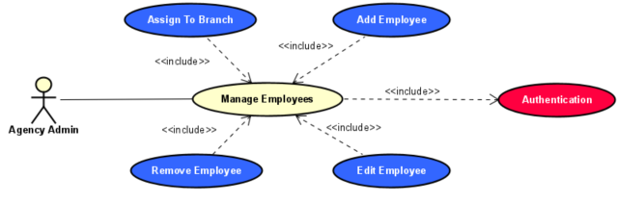
UC-9.1: Add Employee
Trigger: Administrator selects add employee.
Goal: Create a new employee account.
Primary Actor: Agency Admin
Precondition: Administrator is authenticated.
Main Success Scenario
- Administrator enters employee information.
- System validates the data.
- System creates the employee account.
- System assigns appropriate permissions.
Alternative Flows
A1. Employee already exists → System displays an error.
Postcondition: Employee account is created.

UC-9.2: Edit Employee
Trigger: Administrator selects edit employee.
Goal: Modify employee information.
Primary Actor: Agency Admin
Precondition: Employee exists.
Main Success Scenario
- Administrator selects an employee.
- System displays employee details.
- Administrator updates information.
- System validates changes.
- System saves updates.
Alternative Flows
A1. Invalid data → System requests correction.
Postcondition: Employee information is updated.

UC-9.3: Remove Employee
Trigger: Administrator selects remove employee.
Goal: Remove an employee account.
Primary Actor: Agency Admin
Precondition: Employee exists.
Main Success Scenario
- Administrator selects an employee.
- System requests confirmation.
- Administrator confirms removal.
- System removes the employee account.
Alternative Flows
A1. Employee has active responsibilities → System rejects removal.
Postcondition: Employee account is removed.

UC-9.4: Assign To Branch
Trigger: Administrator selects employee assignment.
Goal: Assign an employee to a branch.
Primary Actor: Agency Admin
Preconditions
- Employee exists.
- Branch exists.
Main Success Scenario
- Administrator selects an employee.
- Administrator selects a branch.
- System validates the assignment.
- System updates employee records.
Alternative Flows
A1. Branch capacity exceeded → System displays an error.
Postcondition: Employee is assigned to the selected branch.

UC-10: Manage Fleet
Trigger: Agency user selects fleet management.
Goal: Allow agencies to manage their vehicle inventory.
Primary Actor: Agency User
Preconditions
- Agency user is authenticated.
Main Success Scenario
- Agency user opens fleet management.
- System displays current vehicles.
- Agency user adds, edits, or removes vehicle information.
- Agency user uploads vehicle photographs.
- System validates the information.
- System updates fleet records.
Alternative Flows
A1. Invalid vehicle data → System requests correction.
A2. Vehicle already exists → System displays an error.
Extension Points
- Add Vehicle
- Edit Vehicle
- Remove Vehicle
Postconditions
- Fleet information is updated.
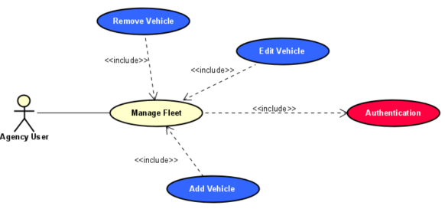
UC-11: Manage Pricing
Trigger: Agency user selects the pricing management function.
Goal: Allow rental agencies to configure vehicle pricing policies.
Primary Actor: Agency User
Preconditions
- Agency user is authenticated.
- Agency account is active.
- Vehicles exist in the fleet.
Main Success Scenario
- Agency user opens the pricing management page.
- System displays the agency's vehicles and pricing information.
- Agency user selects a vehicle.
- Agency user configures pricing rules, seasonal rates, and deposit requirements.
- System validates the entered data.
- System updates the pricing information.
Alternative Flows
A1. Invalid pricing information → System requests correction.
A2. Vehicle not found → System displays an error message.
Extension Points
- Apply Seasonal Pricing
- Create Discounts
Postconditions
- Vehicle pricing information is updated.
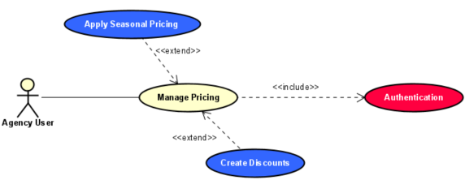

UC-12: Manage Availability
Trigger: Agency user selects availability management.
Goal: Allow agencies to manage vehicle availability schedules.
Primary Actor: Agency User
Preconditions
- Agency user is authenticated.
- Vehicle records exist.
Main Success Scenario
- Agency user opens the availability management page.
- System displays available vehicles.
- Agency user selects a vehicle.
- Agency user updates availability schedules or status.
- System validates the changes.
- System updates the availability information.
Alternative Flows
A1. Invalid availability period → System requests correction.
A2. Vehicle unavailable for update → System displays an error.
Extension Points
- Mark Vehicle Under Maintenance
- Set Availability Schedule
Postconditions
- Vehicle availability is updated.

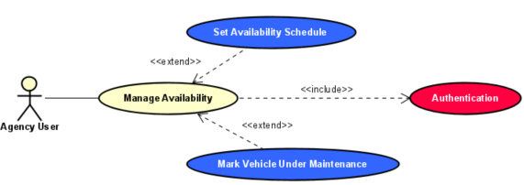
UC-13: Manage Customers
Trigger: Agency user selects customer management.
Goal: Allow agencies to access customer rental information.
Primary Actor: Agency User
Preconditions
- Agency user is authenticated.
- Customer records exist.
Main Success Scenario
- Agency user opens customer management.
- System displays customer records.
- Agency user selects a customer.
- System displays customer information.
- Agency user reviews customer history and rental records.
Alternative Flows
A1. Customer not found → System displays an error.
Extension Points
- View Customer History
- View Rental Records
Postconditions
- Customer information is displayed.
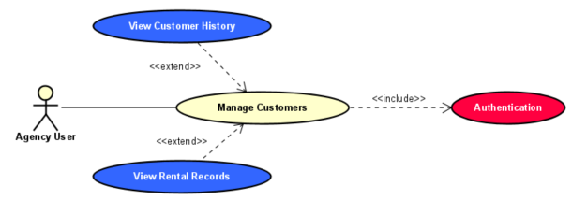
UC-13.1: View Customer History
Trigger: Agency user selects a customer history request.
Goal: Allow agencies to review customer activity history.
Primary Actor: Agency User
Preconditions
- Agency user is authenticated.
- Customer records exist.
Main Success Scenario
- Agency user selects a customer.
- System retrieves customer history.
- System displays previous reservations and activities.
Alternative Flows
A1. No history available → System displays a notification.
Postcondition: Customer history is displayed.

UC-13.2: View Rental Records
Trigger: Agency user requests rental records.
Goal: Allow agencies to review historical rental transactions.
Primary Actor: Agency User
Preconditions
- Agency user is authenticated.
- Rental records exist.
Main Success Scenario
- Agency user selects rental records.
- System retrieves historical rentals.
- System displays rental information.
Alternative Flows
A1. No records found → System displays a notification.
Postcondition: Rental records are displayed.

UC-14: Manage Reservations
Trigger: Agency user accesses reservation management.
Goal: Allow agencies to process customer reservation requests.
Primary Actor: Agency User
Preconditions
- Agency user is authenticated.
- Reservation requests exist.
Main Success Scenario
- Agency user opens reservation management.
- System displays reservation requests.
- Agency user selects a reservation.
- Agency user reviews reservation details.
- Agency user accepts or rejects the reservation.
- System updates reservation status.
- System notifies the customer.
Alternative Flows
A1. Reservation no longer available → System displays an error.
A2. Reservation data incomplete → System requests correction.
Extension Points
- Accept Reservation
- Reject Reservation
- Complete Reservation
Postconditions
- Reservation status is updated.
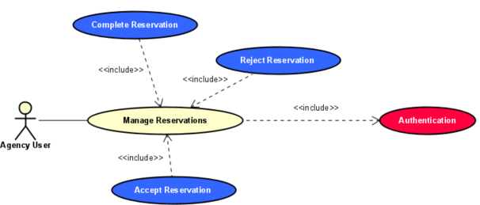

UC-15: View Reports
Trigger: Agency user accesses the reporting dashboard.
Goal: Allow agencies to review operational and financial reports.
Primary Actor: Agency User
Secondary Actor: AI Service Provider
Preconditions
- Agency user is authenticated.
- Reporting data exists.
Main Success Scenario
- Agency user opens the reporting dashboard.
- System retrieves operational statistics.
- System displays reports and analytics.
- Agency user reviews revenue, reservations, and fleet utilization.
- Agency user optionally requests AI-generated insights.
- System displays analytical insights.
Alternative Flows
A1. Report data unavailable → System displays an error.
A2. AI analysis service unavailable → System displays reports without AI insights.
Extension Points
- Generate AI Insights
Postconditions
- Reports and analytics are displayed.

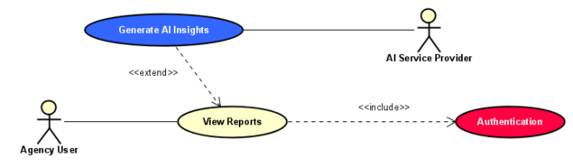
UC-15.1: Generate AI Insights
Trigger: Agency user requests analytical insights.
Goal: Generate AI-powered business insights and recommendations.
Primary Actor: Agency User
Secondary Actor: AI Service Provider
Preconditions
- Agency user is authenticated.
- Historical operational data exists.
Main Success Scenario
- Agency user requests AI analysis.
- System sends data to the AI service.
- AI service analyzes operational data.
- System receives generated insights.
- System displays recommendations and forecasts.
Alternative Flows
A1. AI service unavailable → System displays a notification.
Postconditions
- AI-generated insights are displayed.

UC-16: Manage Agency Finances
Trigger: Agency user accesses financial management.
Goal: Allow agencies to monitor their financial transactions and revenue.
Primary Actor: Agency User
Secondary Actor: Payment Service Provider
Preconditions
- Agency user is authenticated.
- Financial records exist.
Main Success Scenario
- Agency user opens the financial dashboard.
- System retrieves transaction records.
- System displays revenue and payment information.
- Agency user reviews financial details.
- Agency user exports or records financial data.
Alternative Flows
A1. Financial service unavailable → System displays an error.
Extension Points
- Generate Financial Report
- Export Transactions
Postconditions
- Financial information is displayed and recorded.
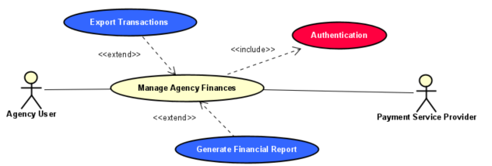
(Agency Management)
UC-17: Register Account
Trigger: Guest selects the registration option.
Goal: Allow new users to create an account.
Primary Actor: Guest
Preconditions
- System is operational.
- User is not already authenticated.
Main Success Scenario
- Guest opens the registration page.
- Guest enters required personal information.
- System validates the entered information.
- Guest submits the registration form.
- System creates the account.
- System confirms successful registration.
Alternative Flows
A1. Email already exists → System displays an error message.
A2. Invalid information provided → System requests correction.
Postconditions
- A new customer account is created.

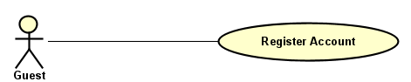
UC-18: Manage Account
Trigger: Customer selects account management.
Goal: Allow customers to manage their account information.
Primary Actor: Customer/Tourist
Preconditions
- Customer is authenticated.
Main Success Scenario
- Customer accesses account settings.
- System displays account information.
- Customer modifies account settings.
- System validates the changes.
- System updates account information.
Alternative Flows
A1. Invalid information → System requests correction.
Extension Points
- Update Profile
- Authentication
Postconditions
- Account information is updated.

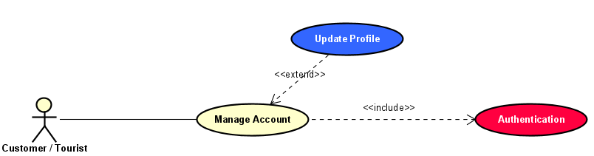
UC-18.1: Update Profile
Trigger: Customer selects profile update.
Goal: Allow customers to update personal profile information.
Primary Actor: Customer/Tourist
Preconditions
- Customer is authenticated.
Main Success Scenario
- Customer opens the profile page.
- System displays current profile information.
- Customer modifies profile details.
- System validates the changes.
- System updates the profile.
Alternative Flows
A1. Invalid data entered → System requests correction.
Postconditions
- Customer profile is updated.

UC-19: Search Vehicles
Trigger: User initiates vehicle search.
Goal: Allow users to search available vehicles.
Primary Actor: Guest, Customer/Tourist
Secondary Actor: Maps Service Provider
Preconditions
- System is operational.
Main Success Scenario
- User opens search page.
- User enters search criteria.
- System retrieves matching vehicles.
- System displays search results.
Alternative Flows
A1. No vehicles found → System displays notification.
A2. Invalid criteria → System requests correction.
Extension Points
- Apply Filters
- Compare Vehicles
Postconditions
- Matching vehicles are displayed.
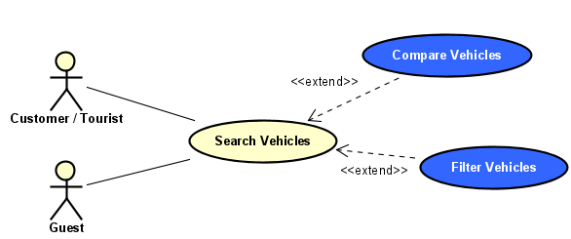

UC-19.1: Compare Vehicles
Trigger: User selects multiple vehicles for comparison.
Goal: Allow users to compare vehicle offers.
Primary Actor: Guest, Customer/Tourist
Precondition: Search results are available.
Main Success Scenario
- User selects multiple vehicles.
- System retrieves vehicle information.
- System displays a comparison table.
- User reviews vehicle specifications and prices.
Alternative Flows
A1. Less than two vehicles selected → System requests additional selection.
Extension Points
- Search Vehicles
Postcondition: Vehicle comparison is displayed.

UC-19.2: Apply Filters
Trigger: User selects filtering options.
Goal: Allow users to refine search results.
Primary Actor: Guest, Customer/Tourist
Precondition: Search results exist.
Main Success Scenario
- User selects filtering criteria.
- System applies selected filters.
- System updates the displayed results.
Alternative Flows
A1. No matching vehicles → System displays a notification.
Extension Points
- Search Vehicles
Postcondition: Filtered search results are displayed.
UC-20: View Vehicle Details
Trigger: User selects a vehicle.
Goal: Allow users to view detailed vehicle information.
Primary Actor: Guest, Customer/Tourist
Preconditions
- Vehicle exists.
Main Success Scenario
- User selects a vehicle.
- System retrieves vehicle information.
- System displays vehicle details, images, pricing, and rental conditions.
Alternative Flows
A1. Vehicle unavailable → System displays an error message.
Extension Points
- Save Favorite Vehicles
Postconditions
- Vehicle details are displayed.

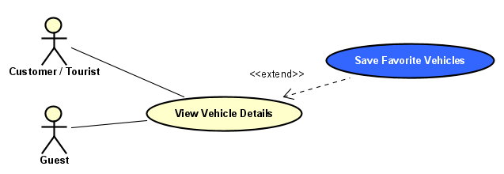
UC-20.1: Save Favorite Vehicles
Trigger: Customer selects the save option.
Goal: Allow customers to save vehicles for future reference.
Primary Actor: Customer/Tourist
Preconditions
- Customer is authenticated.
- Vehicle information is displayed.
Main Success Scenario
- Customer selects a vehicle.
- Customer clicks save.
- System stores the vehicle in favorites.
- System confirms the operation.
Alternative Flows
A1. Vehicle already saved → System displays a notification.
Extension Points
- View Vehicle Details
Postconditions
- Vehicle is added to favorites.

UC-21: Ask Questions
Trigger: User submits a question.
Goal: Allow users to obtain assistance and recommendations.
Primary Actor: Guest, Customer/Tourist
Secondary Actor: AI Service Provider
Preconditions
- AI service is available.
Main Success Scenario
- User opens the assistance interface.
- User enters a question.
- System forwards the request to the AI service.
- AI service generates a response.
- System displays the answer.
Alternative Flows
A1. AI service unavailable → System displays an error message.
Extension Points
- Use AI Assistant
Postconditions
- User receives assistance.
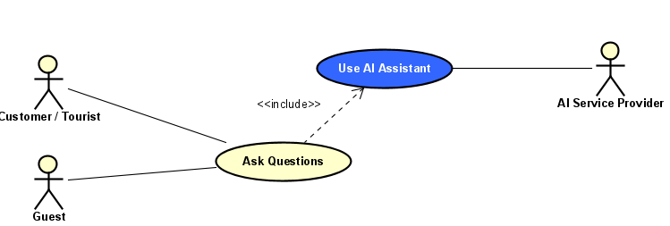

UC-21.1: Use AI Assistant
Trigger: User requests AI assistance.
Goal: Provide intelligent recommendations and support.
Primary Actor: Guest, Customer/Tourist
Secondary Actor: AI Service Provider
Preconditions
- AI service is operational.
Main Success Scenario
- User requests AI assistance.
- System collects user preferences.
- System sends data to the AI service.
- AI service generates recommendations.
- System displays recommendations.
Alternative Flows
A1. No suitable recommendations available → System suggests alternatives.
Postconditions
- Personalized recommendations are displayed.

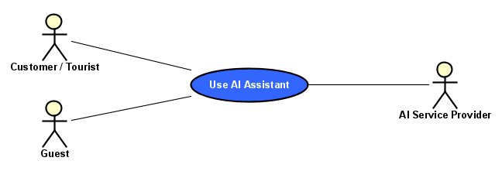
UC-22: Make Reservation
Trigger: Customer selects a vehicle to reserve.
Goal: Allow customers to create rental reservations.
Primary Actor: Customer/Tourist
Preconditions
- Customer is authenticated.
- Selected vehicle is available.
Main Success Scenario
- Customer selects a vehicle.
- System displays reservation details.
- Customer enters reservation information.
- System validates availability.
- Customer confirms reservation.
- System creates the reservation.
- System displays reservation confirmation.
Alternative Flows
A1. Vehicle unavailable → System suggests alternatives.
A2. Reservation information invalid → System requests correction.
Extension Points
- View Reservation Status
- Cancel Reservation
- Modify Reservation
Postconditions
- Reservation is created.
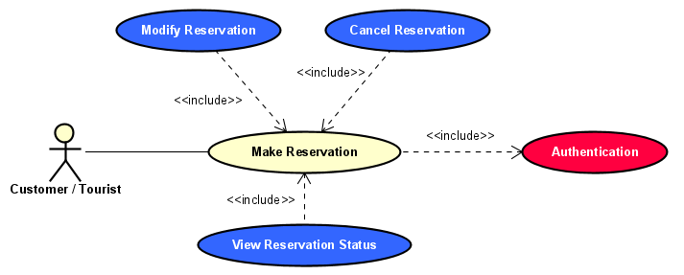

UC-22.1: View Reservation Status
Trigger: Customer requests reservation status.
Goal: Allow customers to track reservations.
Primary Actor: Customer/Tourist
Preconditions
- Customer is authenticated.
- Reservation exists.
Main Success Scenario
- Customer opens reservations.
- System retrieves reservation data.
- System displays reservation status.
Alternative Flows
A1. Reservation not found → System displays an error.
Postcondition: Reservation status is displayed.

UC-22.2: Cancel Reservation
Trigger: Customer selects reservation cancellation.
Goal: Allow customers to cancel reservations.
Primary Actor: Customer/Tourist
Preconditions
- Customer is authenticated.
- Reservation exists.
- Cancellation policy allows cancellation.
Main Success Scenario
- Customer selects a reservation.
- Customer requests cancellation.
- System displays cancellation details.
- Customer confirms cancellation.
- System updates reservation status.
- System notifies the rental agency.
Alternative Flows
A1. Cancellation not permitted → System displays a notification.
Postcondition: Reservation is cancelled.
UC-22.3: Modify Reservation
Trigger: Customer selects reservation modification.
Goal: Allow customers to modify reservation details.
Primary Actor: Customer/Tourist
Preconditions
- Customer is authenticated.
- Reservation exists.
Main Success Scenario
- Customer selects a reservation.
- System displays reservation details.
- Customer modifies reservation information.
- System validates availability.
- System updates the reservation.
Alternative Flows
A1. Vehicle unavailable → System suggests alternatives.
A2. Modification not permitted → System displays an error.
Postcondition: Reservation information is updated.

UC-23: Make Payments
Trigger: Customer proceeds to payment.
Goal: Allow customers to pay for reservations.
Primary Actor: Customer/Tourist
Secondary Actor: Payment Service Provider
Preconditions
- Customer is authenticated.
- Reservation exists.
Main Success Scenario
- Customer selects payment.
- System displays payment details.
- Customer enters payment information.
- System sends the payment request.
- Payment service validates the transaction.
- System confirms successful payment.
Alternative Flows
A1. Payment declined → System displays an error message.
A2. Payment service unavailable → System requests retry.
Postconditions
- Payment is processed.
- Payment record is stored.

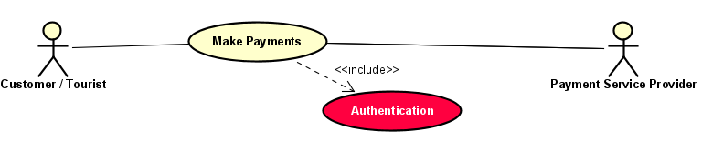
UC-24: Submit Reviews & Ratings
Trigger: Customer submits a review after completing a reservation.
Goal: Allow customers to rate rental agencies and services.
Primary Actor: Customer/Tourist
Preconditions
- Customer is authenticated.
- Reservation has been completed.
Main Success Scenario
- Customer opens the review page.
- System displays completed reservations.
- Customer selects a reservation.
- Customer enters a rating and review.
- System validates the submission.
- System stores the review.
- System confirms successful submission.
Alternative Flows
A1. Customer already submitted a review → System displays a notification.
A2. Review content violates policy → System rejects the submission.
Postconditions
- Review and rating are stored in the system.
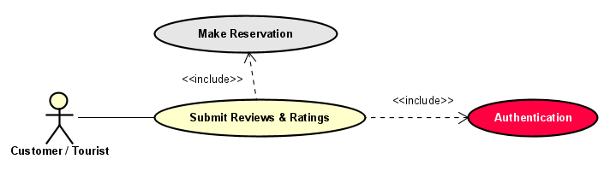
(Mobile Application)
UC-25: Access Offline Data
Trigger: User attempts to access previously viewed information while offline.
Goal: Allow users to access cached vehicle information without an internet connection.
Primary Actor: Customer/Tourist
Preconditions
- User has previously viewed vehicle information.
- Cached data exists on the mobile device.
Main Success Scenario
- User opens the mobile application while offline.
- System detects the absence of an internet connection.
- System retrieves cached vehicle data.
- System displays the available offline information.
- User browses the cached content.
Alternative Flows
A1. No cached data available → System displays a notification.
A2. Cached data is corrupted → System requests an internet connection.
Extension Points
- Refresh Cached Data
Postconditions
- Available offline data is displayed.

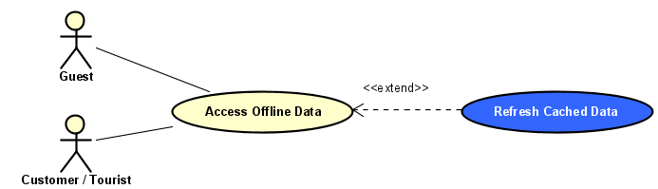
UC-26: Quick Book
Trigger: User selects the quick booking option.
Goal: Allow users to create reservations through a simplified booking process.
Primary Actor: Customer/Tourist
Secondary Actor: Maps Service Provider
Preconditions
- User is authenticated.
- Selected vehicle is available.
Main Success Scenario
- User selects a vehicle.
- User chooses the quick booking option.
- System automatically fills available user information.
- User confirms reservation details.
- System validates vehicle availability.
- System creates the reservation.
- System displays the booking confirmation.
Alternative Flows
A1. Vehicle unavailable → System suggests alternative vehicles.
A2. Required information missing → System requests additional information.
Postconditions
- Reservation is successfully created.

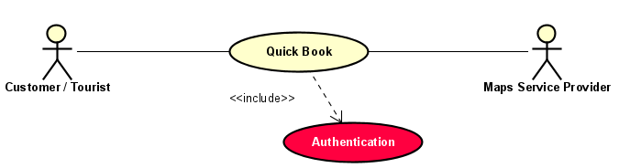
UC-27: Receive Push Notification
Trigger: System generates a notification event.
Goal: Notify users about reservation updates and system events.
Primary Actor: Guest, Customer/Tourist
Preconditions
- User has enabled push notifications.
- Mobile application is registered for notifications.
Main Success Scenario
- A system event occurs (confirmation, update, reminder, etc.).
- System generates a notification message.
- Notification service delivers the message.
- User receives the push notification.
- User opens the notification.
- System displays the related information.
Alternative Flows
A1. Notification service unavailable → System retries delivery.
A2. User disabled notifications → Notification is not delivered.
Postconditions
- Notification is delivered or queued for delivery.

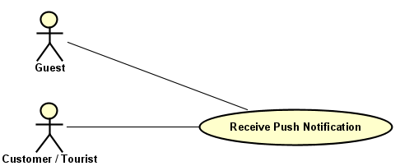
UC-28: View Nearby Agencies
Trigger: User requests nearby rental agencies.
Goal: Allow users to locate rental agencies near their current location.
Primary Actor: Guest, Customer/Tourist
Secondary Actor: Maps Service Provider
Preconditions
- User has granted location permission.
- Internet connection is available.
Main Success Scenario
- User selects nearby agencies.
- System retrieves the user's current location.
- System requests nearby agency information.
- System retrieves matching agencies.
- System displays nearby agencies on a map and in a list.
Alternative Flows
A1. Location permission denied → System requests permission.
A2. No nearby agencies found → System displays a notification.
Extension Points
- Use Location Services
Postconditions
- Nearby agencies are displayed.

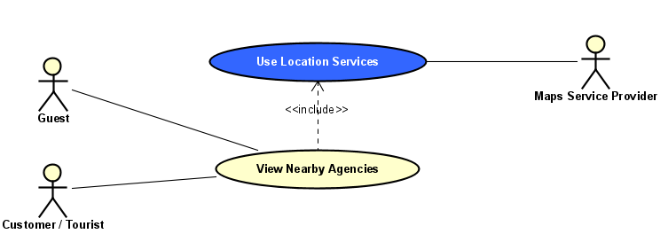
UC-28.1: Use Location Services
Trigger: User enables location-based features.
Goal: Provide location-aware recommendations and services.
Primary Actor: Guest, Customer/Tourist
Secondary Actor: Maps Service Provider
Preconditions
- Mobile device location services are enabled.
- User grants location permission.
Main Success Scenario
- User enables location services.
- System requests location permission.
- User grants permission.
- System retrieves the user's current location.
- System identifies nearby rental agencies and pickup locations.
- System displays location-based recommendations.
Alternative Flows
A1. User denies permission → System disables location features.
A2. Location service unavailable → System requests manual location entry.
Postconditions
- User location is obtained and location-based services are provided.

Diagrams
For better readability, maintainability and understanding of the system behavior the overall KriGo use case model has been split in four different use case diagrams by main stakeholder groups and system parts. Each diagram is centered on a particular actor category and its associated functionalities. This method allows us to depict complicated interactions in a clear way without overloading a single diagram.
A. Administration Use Cases
The Administration Use Case Diagram depicts the use cases available for the platform’s administrators and financial staff responsible for the operation and supervision of the KriGo platform. These are agency verification, user management, content moderation, dispute management, financial operations and overall platform monitoring. The diagram also illustrates relationships with external monitoring and payment service providers. Administrative functions provide governance, operational integrity, compliance and effective management of all stakeholders in the marketplace.
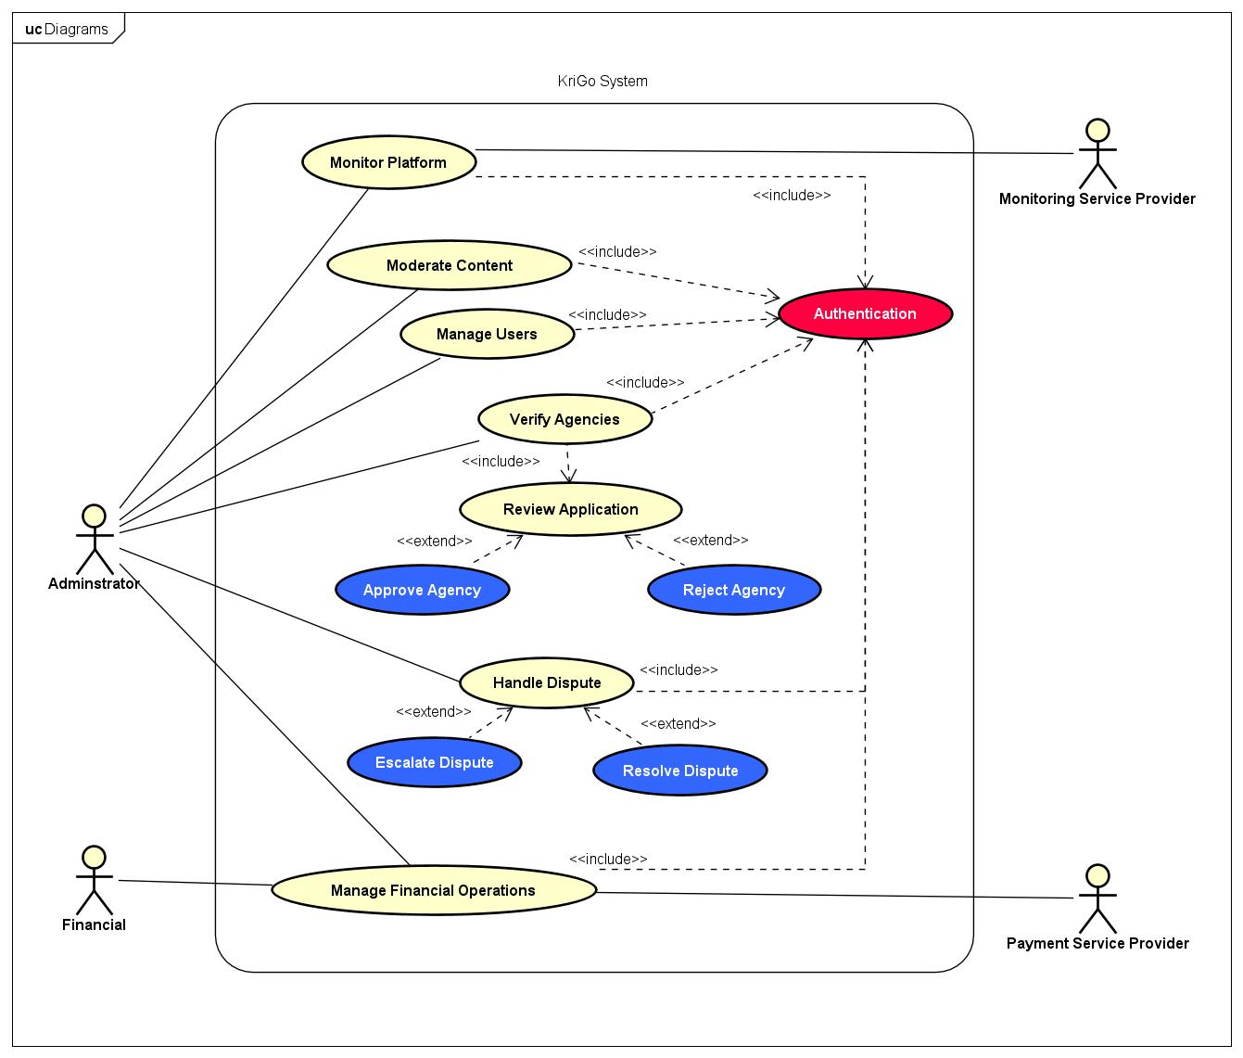
B. Rental Agency Use Cases
The Rental agency Use Case Diagram depicts the activities of the rental agencies and their employees. It covers fleet management, price management, availability management, reservation handling, customer management, finance management, branch management, employee management and reporting. The diagram also includes AI-powered analytics services that offer business insights, and external services, for payment processing and location management. The diagram below demonstrates the digital management tools that are given to rental agencies to assist them with running their business.

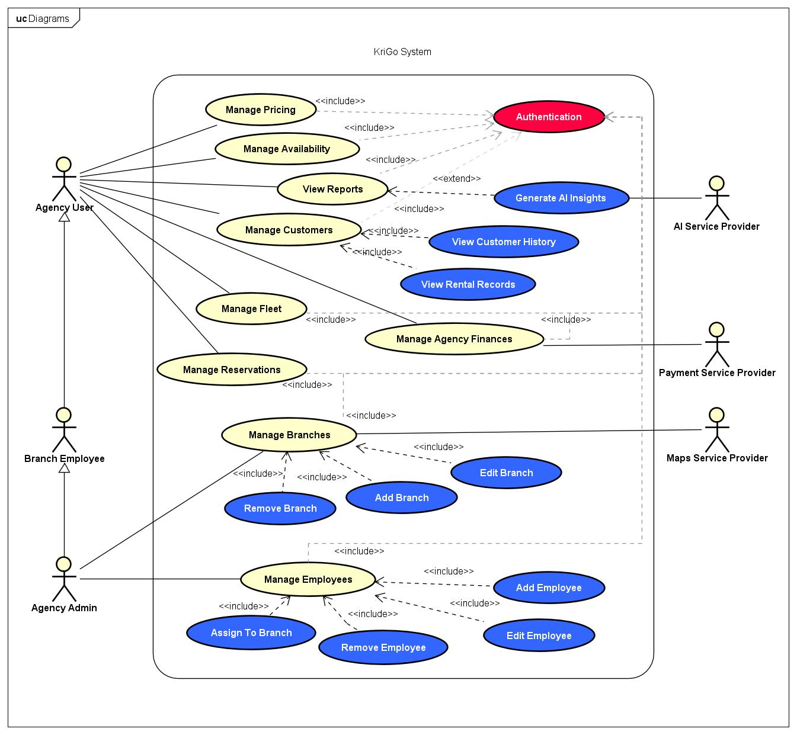

C. Customer/Tourist Use Cases
The Customer/Tourist Use Case Diagram depicts the functionalities accessible to guests and registered customers using the KriGo platform via web applications. It demonstrates the workflow of account management, vehicle discovery, reservation management, online payments, customer reviews and AI powered recommendations. Location services, intelligent recommendations, and secure payment processing are also supported by integrating with external service providers including Maps Service Provider, AI Service Provider, and Payment Service Provider. This diagram is primarily concerned with the customer facing requirements outlined in the system.

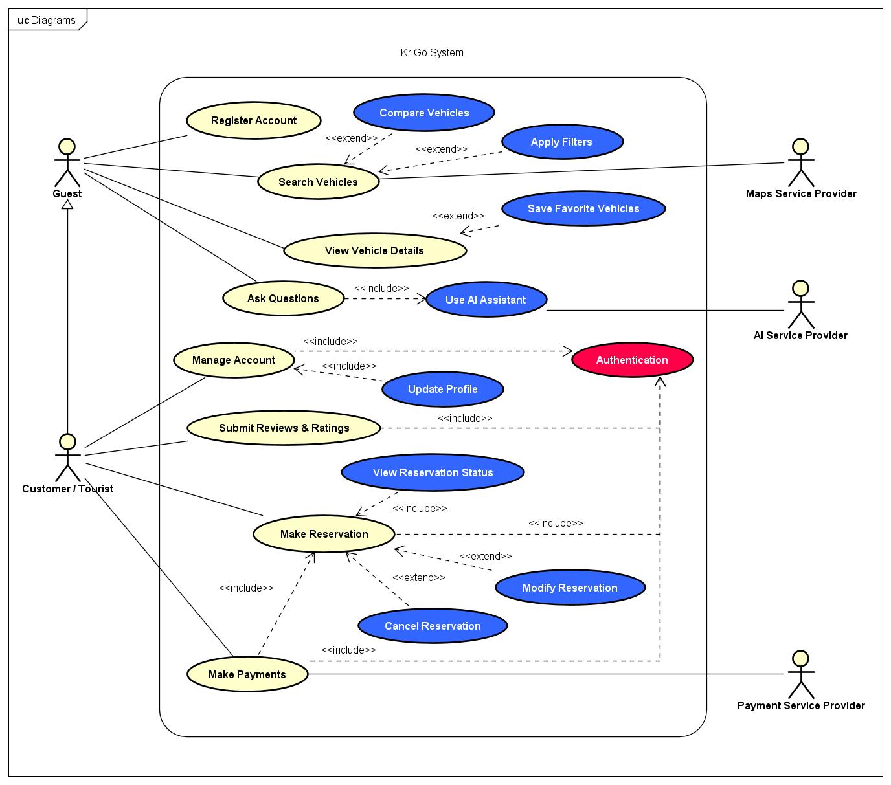

D. Mobile Application Use Cases
Mobile Application Use Case Diagram gives an insight into the functionalities provided through the use of KriGo mobile application. This diagram highlights functions that are specific to the mobile application, which include quick booking, offline capability to access previously accessed information, push notifications, location-based functions, and discovering agencies nearby. Other functions such as reservation and payments are included in this diagram. Some external functions provide help in some of these functions.

